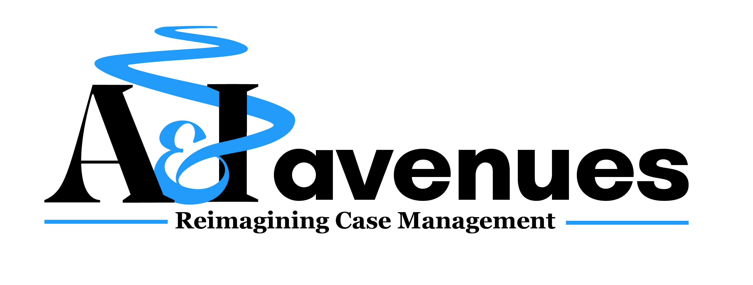
Board of Directors Public Meeting Agenda

All BOD meetings are held virtually at 2:30 p.m. – 4:00 p.m.
March 19, 2025

Board meetings are held virtually on Microsoft Teams. If you are a member of the public and would like to attend this Board of Directors meeting, please contact Cindy Vogels at cvogels@aiavenues.org to register to attend.

This disclaimer is also read at the beginning of each Board meeting:

A&I Avenues is a private, non-profit corporation. We welcome public comments and input
during meetings of our BOD. We are also dedicated to conducting the business of the corporation, meeting our legal duties of care and loyalty, and assuring the financial, operational, and strategic health of the corporation. Public comments are limited to a total of 15 minutes, with the speaker receiving a maximum of 3 minutes. Written comments will be accepted after the meeting if time restrictions have limited any individual’s comments. No PHI should be shared, even if the speaker is speaking about themselves. Microphones will be muted and cameras turned off for any speaker who uses vulgar language or actions or who is disrupting the meeting. We regret that minutes are not transferable.

Topic | Amount of Time projected
Introductions | 5 minutes
Welcome guest(s) if any are in attendance; public comment period | 3 minutes (adjust as needed up to max)
Request and Vote for an Executive Session if Needed | 2 minutes
Review and approval of Minutes from previous meeting | 5 minutes
Discussion of outstanding BOD business | 15 minutes
Financial Report | 10 minutes
Co-CEOs’ report | 20 minutes
Other business topics | 20 minutes
Close of meeting | 5 minutes

